- 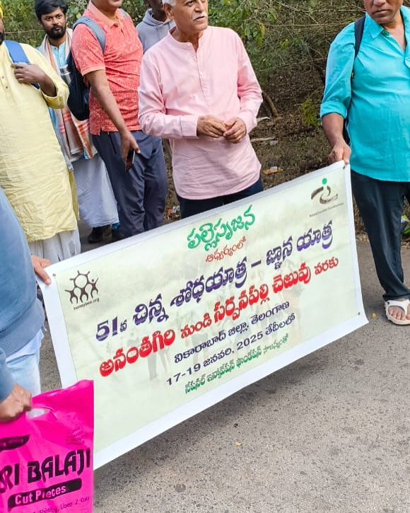
- 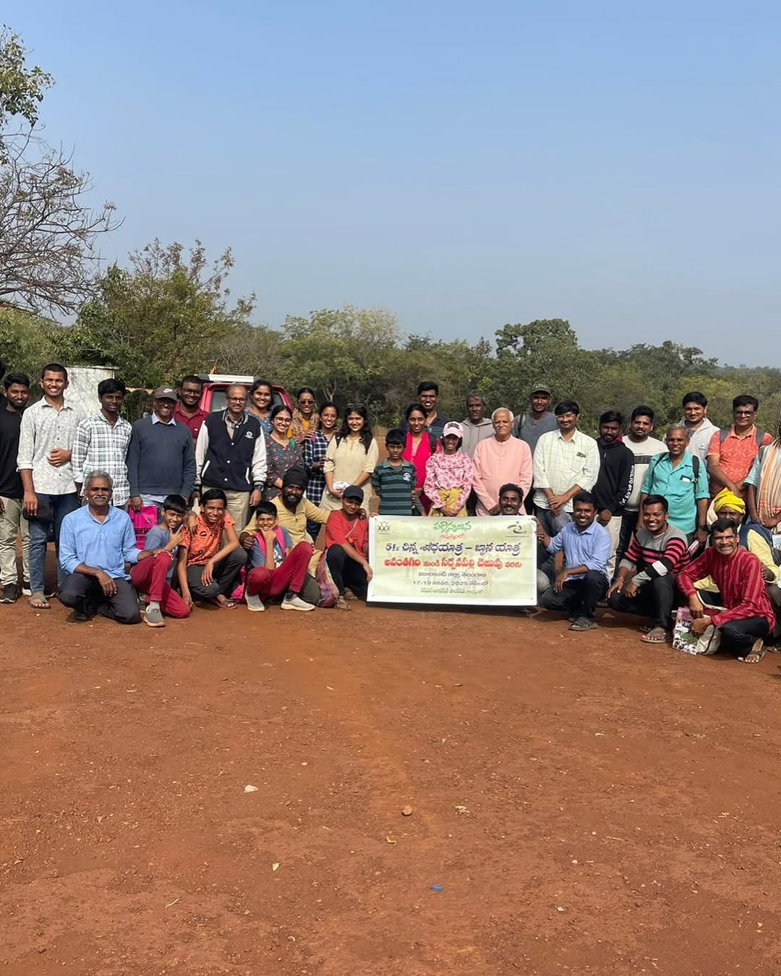

haribabu_sreeramoju

Participated 51st Chinna Shodha Yatra (CSY-51) during Jan 17 to Jan 19th 2025. This yatra is conducted by Palle Srujana team. Before starting the yatra, I had a very narrow view of this yatra thinking just to meet few villagers and explaining them about innovations from rural innovators. But I am very impressed to learn how this yatra is designed with holistic approach. It gave me opportunity to interact with nature, fellow yatris and villagers. The 50+ kilometres walk
covering more than 7 villages gave opportunity to make new friends, listen to their perspectives, observe nature and to talk with passers by, villagers etc. I felt so much of positive energy around talking with people with similar values, learnt a lot talking with them. I have learnt how we can lead life with minimal resources. I am amused by openness, curiosity by villages and school children.
I am very much pleased to interact with Brig Ganesham garu, his team members. Kudos to their simplicity,
focus, determination in encouraging grassroot innovations. I am more than willing to participate in upcoming yatras and to work with Palle Srujana team.

